2017-2018
Buckaroo Nominees
Put a check next to each book as you finish it.

____ 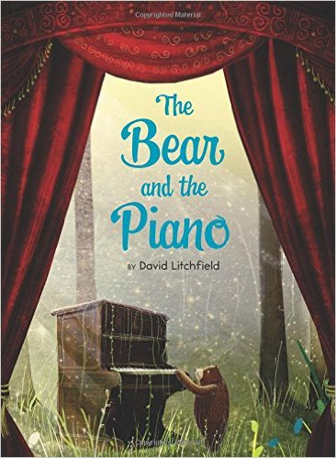 Bear and the Piano
____ 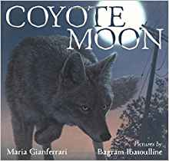 Coyote Moon
____ 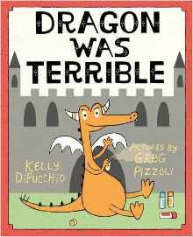 Dragon Was Terrible
____ 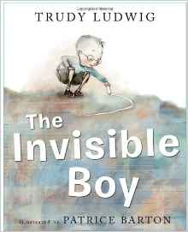 Invisible Boy
____ 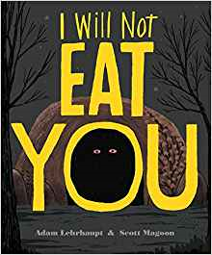 I Will Not Eat You
____ 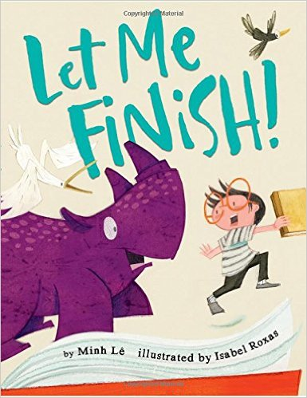 Let Me Finish!
____ 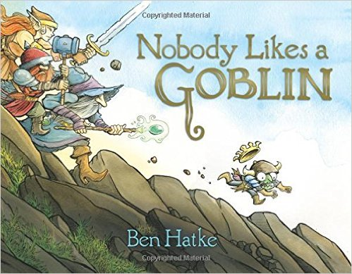 Nobody Likes A Goblin
____ 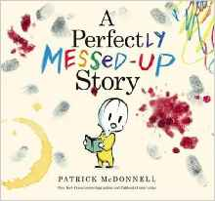 A Perfectly Messed Up Story
____ 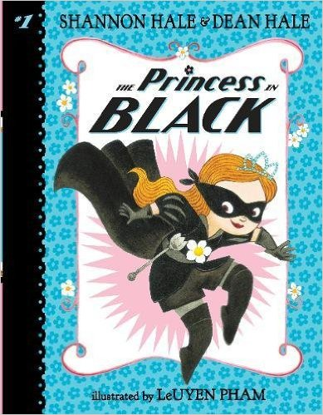 Princess in Black
____ 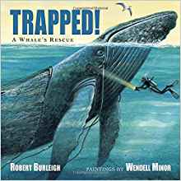 Trapped: A Whale’s Rescue

2017-2018
Buckaroo Nominees
Put a check next to each book as you finish it.

____ Bear and the Piano
____ Coyote Moon
____ Dragon Was Terrible
____ Invisible Boy
____ I Will Not Eat You
____ Let Me Finish!
____ Nobody Likes A Goblin
____ A Perfectly Messed Up Story
____ Princess in Black
____ Trapped: A Whale’s Rescue

2017-2018
Buckaroo Nominees
Put a check next to each book as you finish it.

____ Bear and the Piano
____ Coyote Moon
____ Dragon Was Terrible
____ Invisible Boy
____ I Will Not Eat You
____ Let Me Finish!
____ Nobody Likes A Goblin
____ A Perfectly Messed Up Story
____ Princess in Black
____ Trapped: A Whale’s Rescue

