2017-2018
Indian Paintbrush
Nominees
Put a check next to each book as you finish.

____ 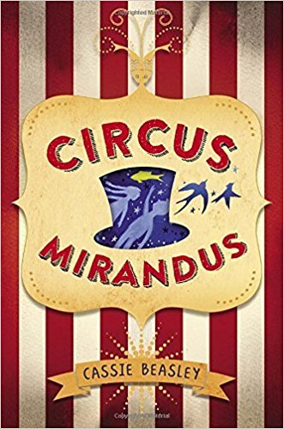 Circus Mirandus
____ 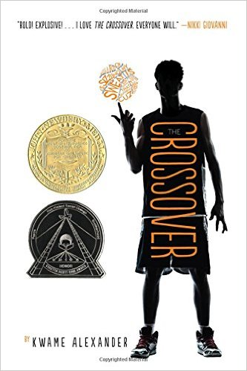 The Crossover
____ 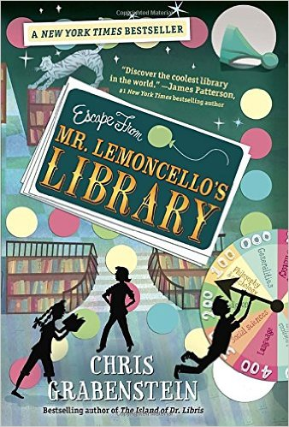 Escape from Mr.
Lemoncello’s Library
____ 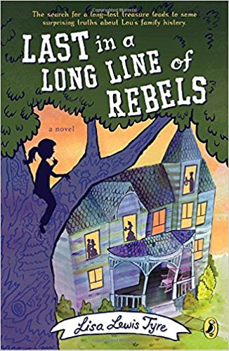 Last in a Long Line of Rebels
____ 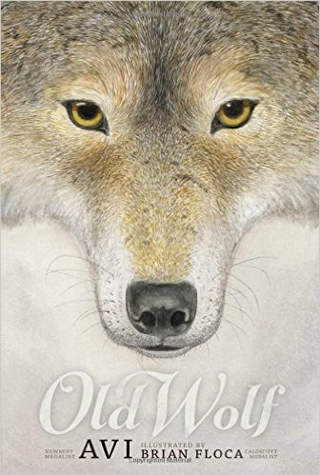 Old Wolf
____ 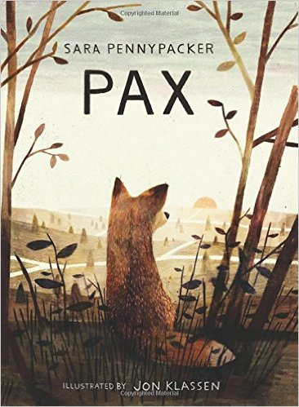 Pax
____ 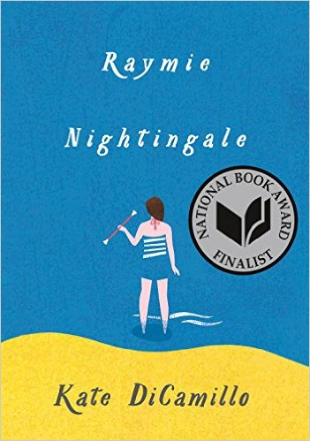 Raymie Nightingale
____ 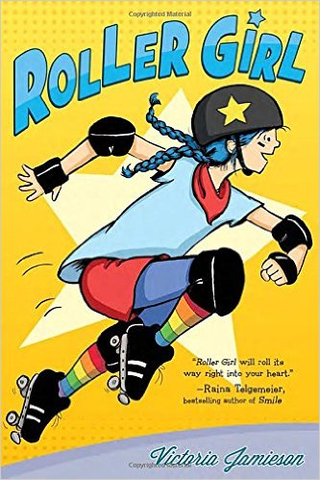 Roller Girl
____ 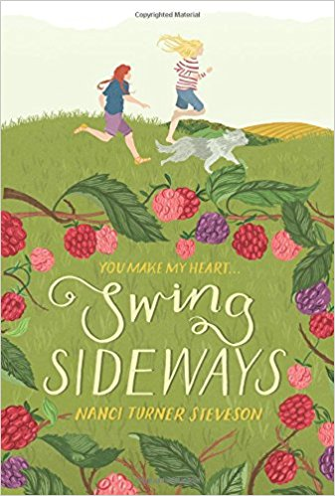 Swing Sideways
____ 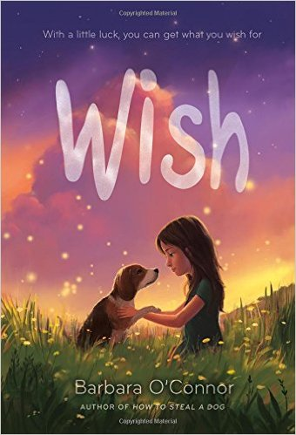 Wish

2017-2018
Indian Paintbrush
Nominees
Put a check next to each book as you finish.

____ Circus Mirandus
____ The Crossover
____ Escape from Mr.
Lemoncello’s Library
____ Last in a Long Line of Rebels
____ Old Wolf
____ Pax
____ Raymie Nightingale
____ Roller Girl
____ Swing Sideways
____ Wish

2017-2018
Indian Paintbrush
Nominees
Put a check next to each book as you finish.

____ Circus Mirandus
____ The Crossover
____ Escape from Mr.
Lemoncello’s Library
____ Last in a Long Line of Rebels
____ Old Wolf
____ Pax
____ Raymie Nightingale
____ Roller Girl
____ Swing Sideways
____ Wish

