2018-2019
Buckaroo Nominees
Put a check next to each book as you finish it.

____ 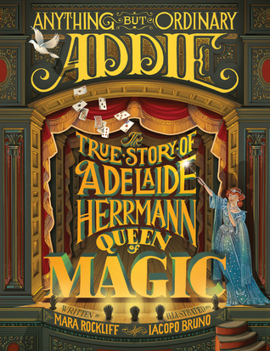 Anything But Ordinary Addie
____ 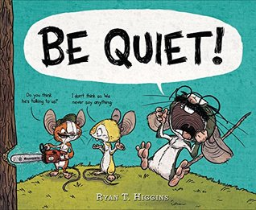 Be Quiet
____ 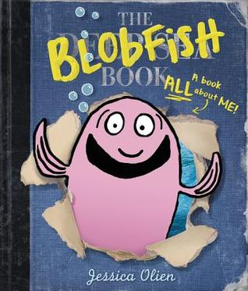 BlobFish
____ 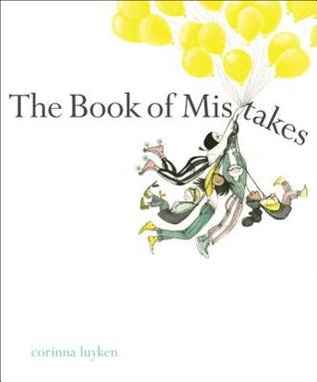 The Book of Mistakes
____ 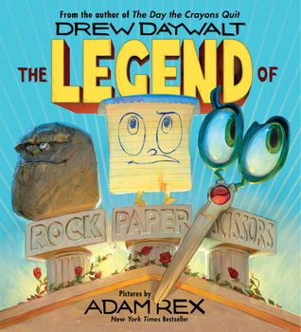 Legend of Rock Paper Scissors
____ 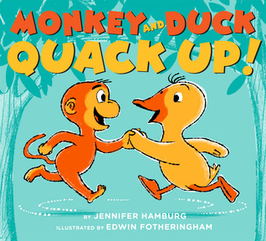 Monkey and Duck Quack Up
____ 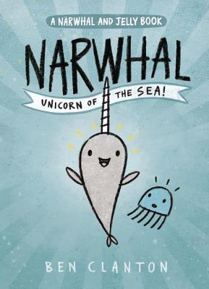 Narwhal, Unicorn of the Sea
____ 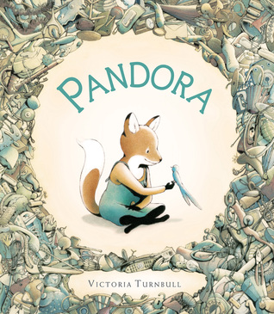 Pandora
____ 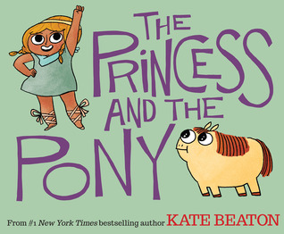 Princess and the Pony
____ 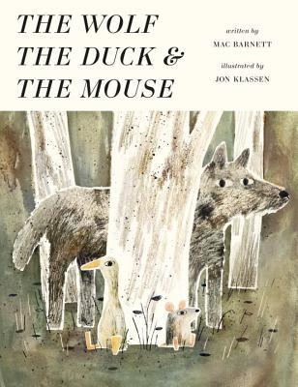 Wolf, the Duck and the Mouse

2018-2019
Buckaroo Nominees
Put a check next to each book as you finish it.

____ Anything But Ordinary Addie
____ Be Quiet
____ BlobFish
____ The Book of Mistakes
____ Legend of Rock Paper Scissors
____ Monkey and Duck Quack Up
____ Narwhal, Unicorn of the Sea
____ Pandora
____ Princess and the Pony
____ Wolf, the Duck and the Mouse

2018-2019
Buckaroo Nominees
Put a check next to each book as you finish it.

____ Anything But Ordinary Addie
____ Be Quiet
____ BlobFish
____ The Book of Mistakes
____ Legend of Rock Paper Scissors
____ Monkey and Duck Quack Up
____ Narwhal, Unicorn of the Sea
____ Pandora
____ Princess and the Pony
____ Wolf, the Duck and the Mouse

