2018-2019
Indian Paintbrush
Nominees
Put a check next to each book as you finish.

____ 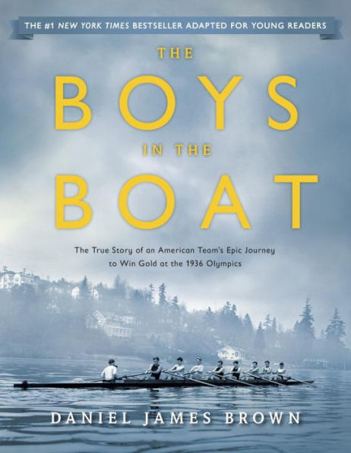 Boys in the Boat
____ 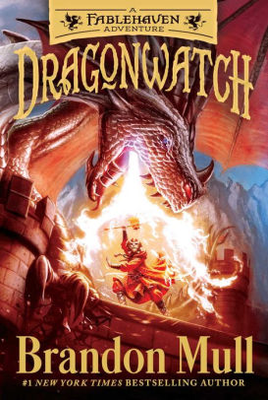 Dragonwatch
____ Ghost
____ 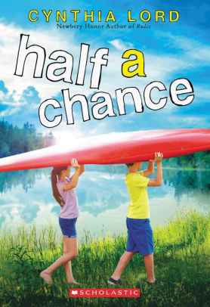 Half a Chance
____ 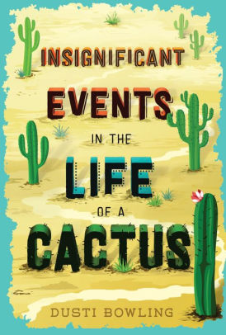 Insignificant Events in
the Life of a Cactus
____ 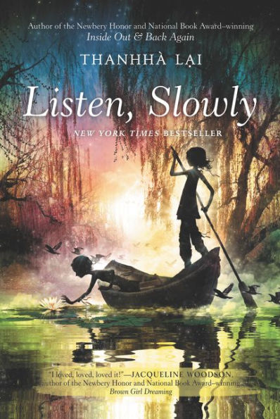 Listen, Slowly
____ 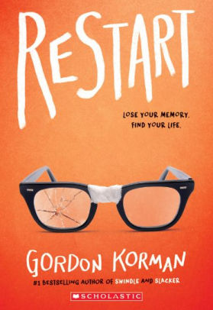 Restart
____ Under Their Skin
____ 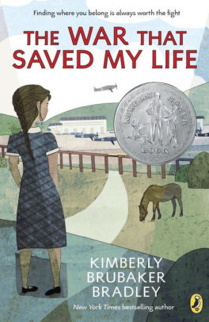War That Saved My Life
____ 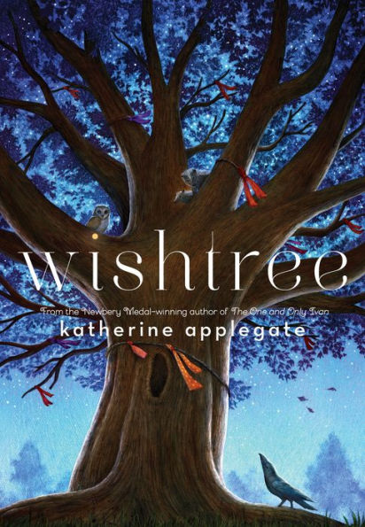 Wishtree

2018-2019
Indian Paintbrush
Nominees
Put a check next to each book as you finish.

____ Boys in the Boat
____ Dragonwatch
____ Ghost
____ Half a Chance
____ Insignificant Events in
the Life of a Cactus
____ Listen, Slowly
____ Restart
____ Under Their Skin
____ War That Saved My Life
____ Wishtree

2018-2019
Indian Paintbrush
Nominees
Put a check next to each book as you finish.

____ Boys in the Boat
____ Dragonwatch
____ Ghost
____ Half a Chance
____ Insignificant Events in
the Life of a Cactus
____ Listen, Slowly
____ Restart
____ Under Their Skin
____ War That Saved My Life
____ Wishtree

